**Project Design Phase**

**Solution Architecture**

|  |  |
| --- | --- |
| Date | 26 -06-2025 |
| Team ID | LTVIP2025TMID55745 |
| Project Name | FreeLance Finder |
| Maximum Marks | 4 Marks |

**Solution Architecture:**

To provide a user-friendly, secure, and scalable freelance project/product sharing and discovery system that bridges the gap between freelancers and product consumers.

- Interactive real-time features such as likes, tags, and search

- Secure and simplified product transactions (buy/download)

- Scalable user authentication and email-based verification

- End-to-end product lifecycle management (Create, Update, Delete)

- Seamless uploading and browsing of freelance products/projects

* End-to-End Patient Management
* Scalable user authentication and authorization
* Secure and trackable payment transactions
* Reliable real-time chat and notifications

**Example - Solution Architecture Diagram:**

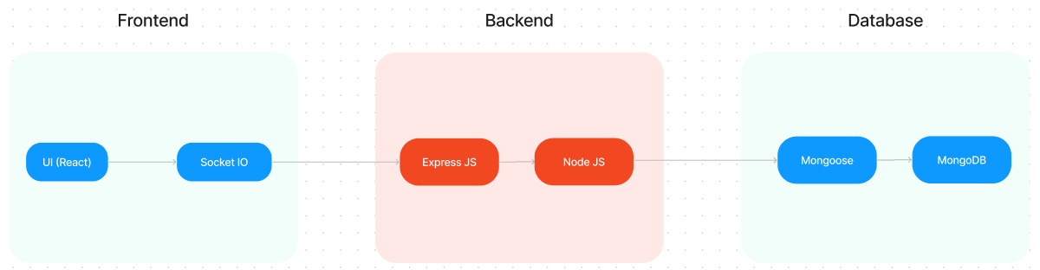

**ER DIAGRAM**

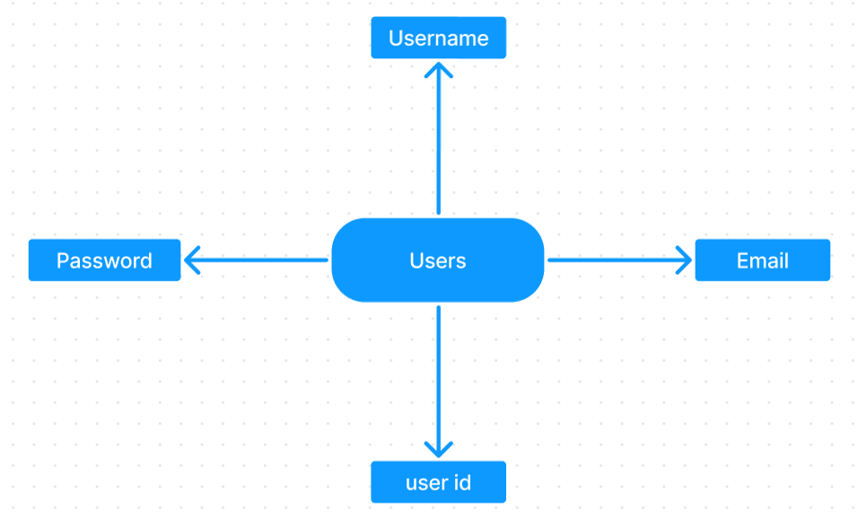

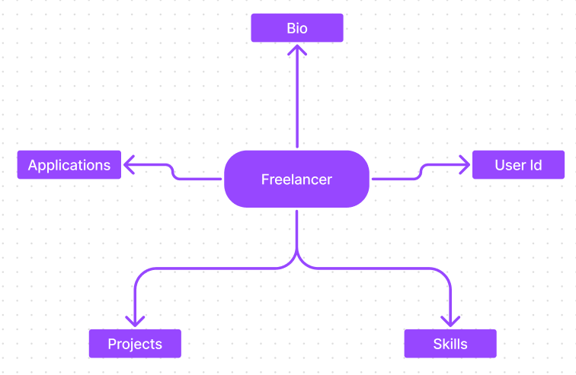

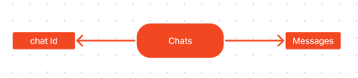

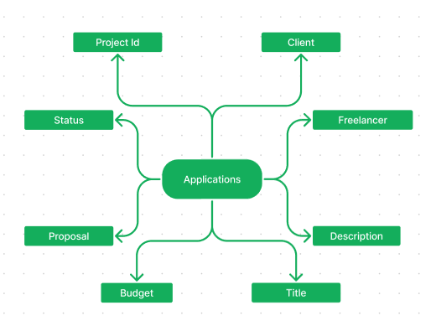

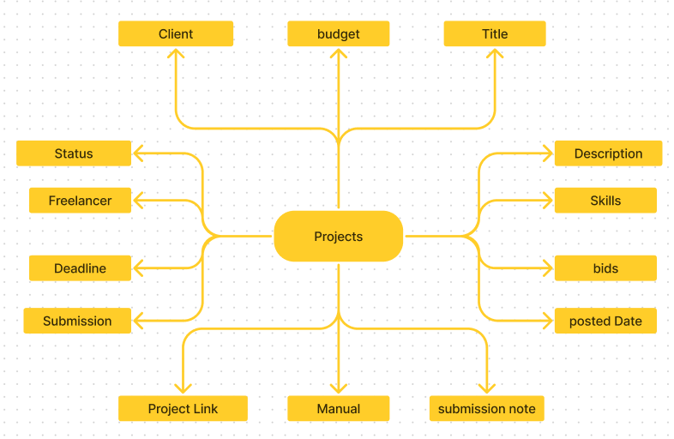

**SB Works connects clients with skilled freelancers through a user-friendly platform. Clients can post projects with details and browse freelancer profiles to find the perfect match. Freelancers can submit proposals, collaborate with clients through secure chat, and securely submit work for review and payment. An admin team ensures quality and communication, making SB Works a go-to platform for both clients and freelancers.**

**PROJECT STRUCTURE**

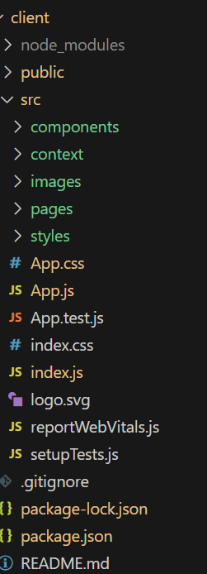 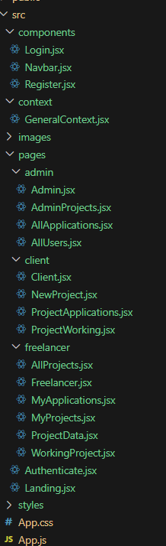 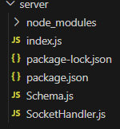

**SB Works leverages React.js for the user interface. The client-side code likely consists of reusable components for profiles, projects, and chat, assembled into pages like project browsing or freelancer profiles. Shared data like user info or search filters might be managed with React Context. On the server side, Node.js handles API requests for user management, project actions, and communication. Mongoose models ensure structured interaction with the MongoDB database. This breakdown provides a foundational understanding of SB Works' architecture.**

**PRE-REQUISTIC:**

**Here are the key prerequisites for developing a full-stack application using Express Js, MongoDB, React.js:**

**✔Node.js and npm:**

**Node.js is a powerful JavaScript runtime environment that allows you to run JavaScript code on the server-side. It provides a scalable and efficient platform for building network applications.**

**Install Node.js and npm on your development machine, as they are required to run JavaScript on the server-side.**

**Download: https://nodejs.org/en/download/**

**Installation instructions:** [**https://nodejs.org/en/download/package-manager/**](https://nodejs.org/en/download/package-manager/)

**✔Express.js:**

**Express.js is a fast and minimalist web application framework for Node.js. It simplifies the process of creating robust APIs and web applications, offering features like routing, middleware support, and modular architecture.**

**Install Express.js, a web application framework for Node.js, which handles server-side routing, middleware, and API development.**

**Installation: Open your command prompt or terminal and run the following command:**

**npm install express**

**✔MongoDB:**

**MongoDB is a flexible and scalable NoSQL database that stores data in a JSON-like format. It provides high performance, horizontal scalability, and seamless integration with Node.js, making it ideal for handling large amounts of structured and unstructured data.**

**Set up a MongoDB database to store your application's data.**

**Download: https://www.mongodb.com/try/download/community**

**Installation instructions:** [**https://docs.mongodb.com/manual/installation/**](https://docs.mongodb.com/manual/installation/)

**✔React.js:**

**React.js is a popular JavaScript library for building user interfaces. It enables developers to create interactive and reusable UI components, making it easier to build dynamic and responsive web applications.**

**Install React.js, a JavaScript library for building user interfaces.**

**Follow the installation guide:** [**https://reactjs.org/docs/create-a-new-react-app.html**](https://reactjs.org/docs/create-a-new-react-app.html)

**✔HTML, CSS, and JavaScript: Basic knowledge of HTML for creating the structure of your app, CSS for styling, and JavaScript for client-side interactivity is essential.**

**✔Database Connectivity: Use a MongoDB driver or an Object-Document Mapping (ODM) library like Mongoose to connect your Express Js server with the MongoDB database and perform CRUD (Create, Read, Update, Delete) operations**

**✔Front-end Framework: Utilize React Js to build the user-facing part of the application, including entering booking room, status of the booking, and user interfaces for the admin dashboard. For making better UI we have also used some libraries like material UI and bootstrap.**

**✔Version Control: Use Git for version control, enabling collaboration and tracking changes throughout the development process. Platforms like GitHub or Bitbucket can host your repository.**

**Git: Download and installation instructions can be found at: https://git-scm.com/downloads**

**✔Development Environment: Choose a code editor or Integrated Development Environment (IDE) that suits your preferences, such as Visual Studio Code, Sublime Text, or WebStorm.**

**• Visual Studio Code: Download from** [**https://code.visualstudio.com/download**](https://code.visualstudio.com/download)

**Install Dependencies:**

**• Navigate into the cloned repository directory:**

**cd freelancer-app-MERN**

**• Install the required dependencies by running the following commands:**

**cd client**

**npm install**

**../cd server**

**npm install**

**Start the Development Server:**

**• To start the development server, execute the following command:**

**npm start**

**• The SB Works app will be accessible at** [**http://localhost:3000**](http://localhost:3000)

**You have successfully installed and set up the SB Works application on your local machine. You can now proceed with further customization, development, and testing as needed.**

**Application flow:**

**Freelancer Responsibilities:**

**• Project Submission: Freelancers are responsible for submitting completed and high-quality work for the assigned projects through the platform.**

**• Compliance: Ensure that the submitted work adheres to client requirements, industry standards, and any specific guidelines outlined by the platform.**

**• Effective Communication: Actively engage in communication with clients, promptly responding to messages, asking clarifying questions, and providing updates on the project progress.**

**• Time Management: Manage time effectively to meet project deadlines and deliver work in a timely manner.**

**• Professionalism: Conduct oneself professionally by maintaining a respectful and cooperative attitude with clients and fellow freelancers.**

**• Quality Assurance: Deliver work that is accurate, well-executed, and free from errors to maintain client satisfaction.**

**Client Responsibilities:**

**• Clear Project Description: Provide a detailed and comprehensive project description, including deliverables, desired outcomes, and any specific requirements.**

**• Timely Communication: Respond promptly to freelancer inquiries, providing necessary information and feedback in a timely manner.**

**• Payment Obligations: Fulfill the agreed-upon payment terms promptly and fairly upon satisfactory completion of the project.**

**• Feedback and Evaluation: Provide constructive feedback and evaluate the freelancer's performance, helping them improve and providing valuable insights.**

**Admin Responsibilities:**

* **Data Oversight: As an admin, one of your key responsibilities is to monitor and ensure the integrity and security of all data on the platform**
* **Policy Enforcement: Admins play a crucial role in enforcing platform policies, guidelines, and ethical standards.**
* **Conflict Resolution: In the event of disputes or issues within the community, it is the admin's responsibility to address them promptly and impartially**
* **User Support and Communication: Admins should provide support and guidance to users on the platform**
* **Platform Maintenance and Improvement: Admins are responsible for the overall maintenance and improvement of the research platform.**

**Project Flow:**

**Use the code in: https://drive.google.com/drive/folders/1TVIcPw74fCk7hQzY90b0ROYH2_U4Xs0V?usp=sharing**

**Milestone 1: Project setup and configuration.**

* **Folder setup:**

**Now, firstly create the folders for frontend and backend to write the respective code and install the essential libraries.**

* **Client folders.**
* **Server folders**

* **Installation of required tools:**

**1. Open the frontend folder to install necessary tools**

**For frontend, we use:**

* **React**
* **Bootstrap**
* **Material UI**
* **Axios**
* **react-bootstrap**

**2. Open the backend folder to install necessary tools**

**For backend, we use:**

* **Express Js**
* **Node JS**
* **MongoDB**
* **Mongoose**
* **Cors**
* **Bcrypt**

**After the installation of all the libraries, the package.json files for the frontend looks like the one mentioned below.**

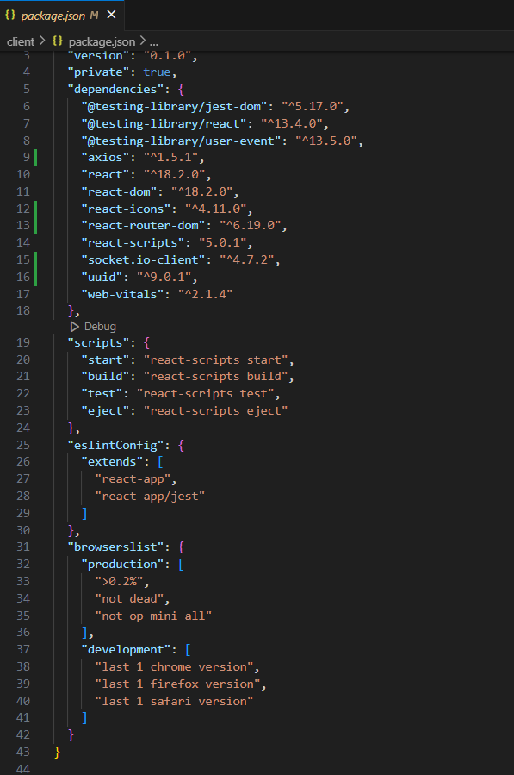

**After the installation of all the libraries, the package.json files for the backend looks like the one mentioned below.**

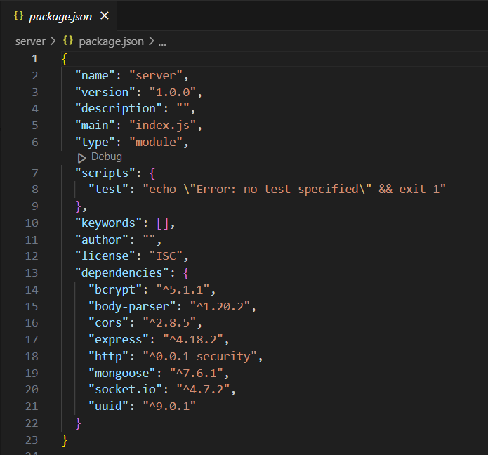

**Milestone 2: Backend Development**

**1. Project Setup:**

* **Create a project directory and initialize it using npm init.**
* **Install required dependencies like Express.js, Mongoose, body-parser, and cors.**

**2. Database Configuration:**

* **Set up a MongoDB database (locally or using a cloud service like MongoDB Atlas).**
* **Create collections for:**
* **Users (storing user information, account type)**
* **Projects (project details, budget, skills required)**
* **Applications (freelancer proposals, rate, portfolio link)**
* **Chat (communication history for each project)**
* **Freelancer (extended user details with skills, experience, ratings)**

**3. Express.js Server:**

* **Create an Express.js server to handle HTTP requests and API endpoints.**
* **Configure body-parser to parse request bodies and cors for cross-origin requests.**

**4. API Routes:**

* **Define separate route files for user management, project listing, application handling, chat functionality, and freelancer profiles.**
* **Implement route handlers using Express.js to interact with the database:**
* **User routes: registration, login, profile management.**
* **Project routes: project creation, listing, details retrieval.**
* **Application routes: submit proposals, view applications.**
* **Chat routes: send and receive messages within projects.**
* **Freelancer routes: view and update profiles, showcase skills.**

**5. Data Models:**

* **Define Mongoose schemas for each data entity:**
* **User schema**
* **Project schema**
* **Application schema**
* **Chat schema**
* **Freelancer schema (extends User schema with skills, experience)**
* **Create Mongoose models to interact with the MongoDB database.**
* **Implement CRUD operations for each model to manage data.**

**6. User Authentication:**

* **Implement user authentication using JWT or session-based methods.**
* **Create routes and middleware for user registration, login, and logout.**
* **Use authentication middleware to protect routes requiring user authorization (e.g., applying for projects).**

**7. Project Management:**

* **Allow clients to post projects with details and budget.**
* **Enable freelancers to browse projects, search by skills, and submit proposals.**
* **Implement a system for clients to review applications and choose freelancers.**

**8. Secure Communication & Collaboration:**

* **Integrate a secure chat system within projects for communication between clients and freelancers.**
* **Allow file attachments and feedback exchange to facilitate collaboration.**

**9. Admin Panel (Optional):**

* **Implement an admin panel with functionalities like:**
* **Managing users**
* **Monitoring project updates and applications**
* **Accessing transaction history**

**Reference video:** [**https://drive.google.com/file/d/1zrOMSp6svjH1tRcul3b442XVPNyKTSp4/view?usp=sharing**](https://drive.google.com/file/d/1zrOMSp6svjH1tRcul3b442XVPNyKTSp4/view?usp=sharing)

**Milestone 3: Database development**

* **Set up a MongoDB database either locally or using a cloud-based MongoDB service like MongoDB Atlas.**
* **Create a database and define the necessary collections for users, freelancer, projects, chats, and applications.**
* **Connect the database to the server with the code provided below.**